

# CA2: Business intelligence- an overview the imports and exports of Ireland

Module Title: Data Visualization & Communications

Module Code: B8IT107

Module Leader: Claire Caulfield

Student Name: Manoj Kumar Thangaraj &

Shane McDonagh

Student Code: 10570753 & 10362717

Contents

CA2:Business intelligence- an overview the imports and exports of Ireland 1

1. Project overview/scope 3

2. Sourcing and cleaning the data 3

3. Exploring and visualising the data 3

4. Creating the story 9

5. Technology used 12

6. Conclusion 13

7. Reflections on learning 13

8. References 13

# Project overview/scope

The scope of this project is to gain a high-level oversight of the exports and imports of Ireland to the outside world. The main reason to carry out this study is to identify the strengths of Ireland with other countries when it comes to imports & exports, and to deal the possible damage caused by Brexit.

Our main goal was to explore the strengths of Ireland’s imports and exports, by commodity and country. Considering Great Britain leaving the European Union, reports of additional taxes, delays, and other checks/certificates, we wanted to see if we could identify new markets to replace GB if needed.

We planned to create a presentation aimed at business owners and the public. The presentation is hosted on Tableau public and has enough information & interactivity that it can be further explored by interested parties if necessary.

# Sourcing and cleaning the data.

We sourced the data from the [Central Statistics office](https://www.cso.ie/en/statistics/externaltrade/archive/releasearchive2020/) website. The data is available monthly, therefore there were higher number files to be downloaded. To avoid the time-consuming work of downloading each and joining it, we requested the data from the CSO officials. The dataset was easy to manipulate in excel because it had a pivot table but appending all the files and matching the countries needed more than excel. We use Pythons and in particular, the Pandas and NumPy libraries.

We loaded the excel sheets into python and ran it through a function to process the sheets. We used Pandas to create a data frame, assign column names, fill in the missing data values and forward filling method for dates. We appended the year to the months column so tableau would auto recognise it. The function output a data frame for each excel sheet, that we concatenated into a larger data frame. Finally, we multiplied the columns with a monetary value by 1000, to show the actual figure in euro. We were also supplied with an excel file with the general description reducing the division descriptions from 100 to 10. This led to easier visualisation, and drill down options. The final data frame had 1.4 million rows of data which exceed the xlsx file limit, but the csv format allowed us to do so.

# Exploring and visualising the data

We created two tableau workbooks - one for the exploring with the data and one for the story.

One of the first things we did was explore the data and ensure it was sufficient for the scope of the project. We created choropleth maps, with sum of export and sum of imports on the colour filter. We had some unknown values which were easily resolved as they were mostly historical variants of modern countries or spelling issues.

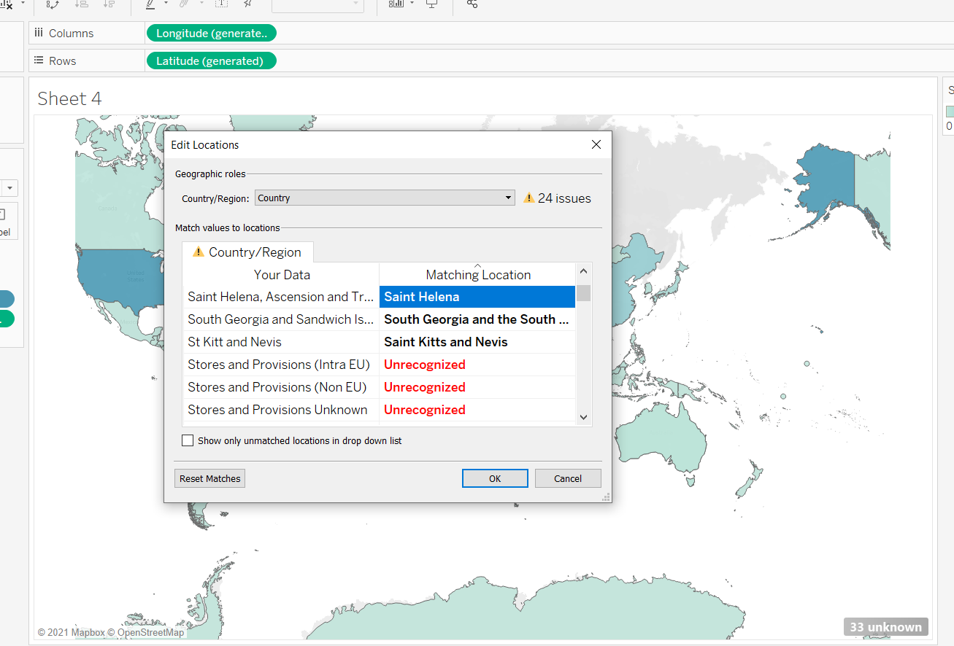

Next, we created diverging bar charts showing the sum of imports/exports and bar charts showing the ranking of the countries.

After gaining an insight into the countries we wanted to explore further, we created bubble diagrams with the division descriptions on colour, and either import or export on size. We explored the relationship of imports and exports by monetary value as well as tonne, to see if the division with the largest cost the largest tonnage was also. We can see an interesting insight with the United States, as the volume of tonne’s exported and imports is considerably lower than the monetary value, indicating that both their exports and imports are of higher monetary values than other countries.

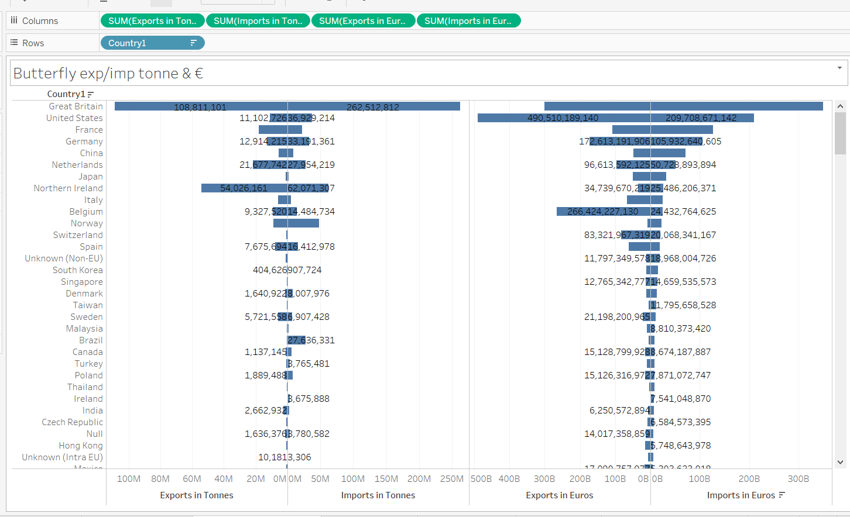

With Northern Ireland, we see the opposite relationship, with a large quantity of tonnes being imported/exported with a low monetary value for both.

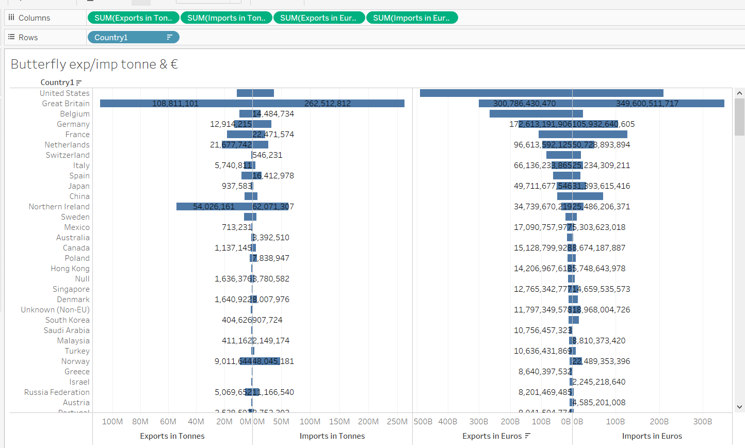

Next, we tried some correlations, using either a calculated field or replication of the variables.

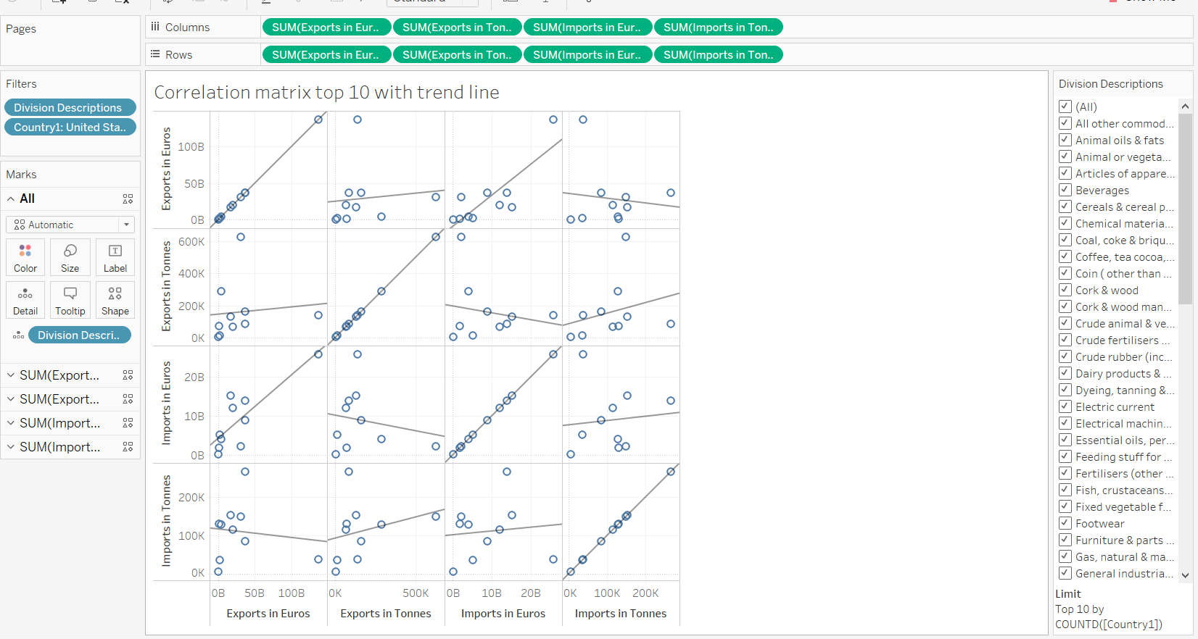

We added trend lines to give a better indication of the overall trend (The trend line shows the R square figure in the tooltip, this is between -1 and 1, with a score of 0 being no correlation).

Later versions of tableau have a function called CORR for this, but we used it to create a heat map with a calculated field to see if there was a correlation for exports and imports in euros. We selected countries with multiple years of data and different ranges.

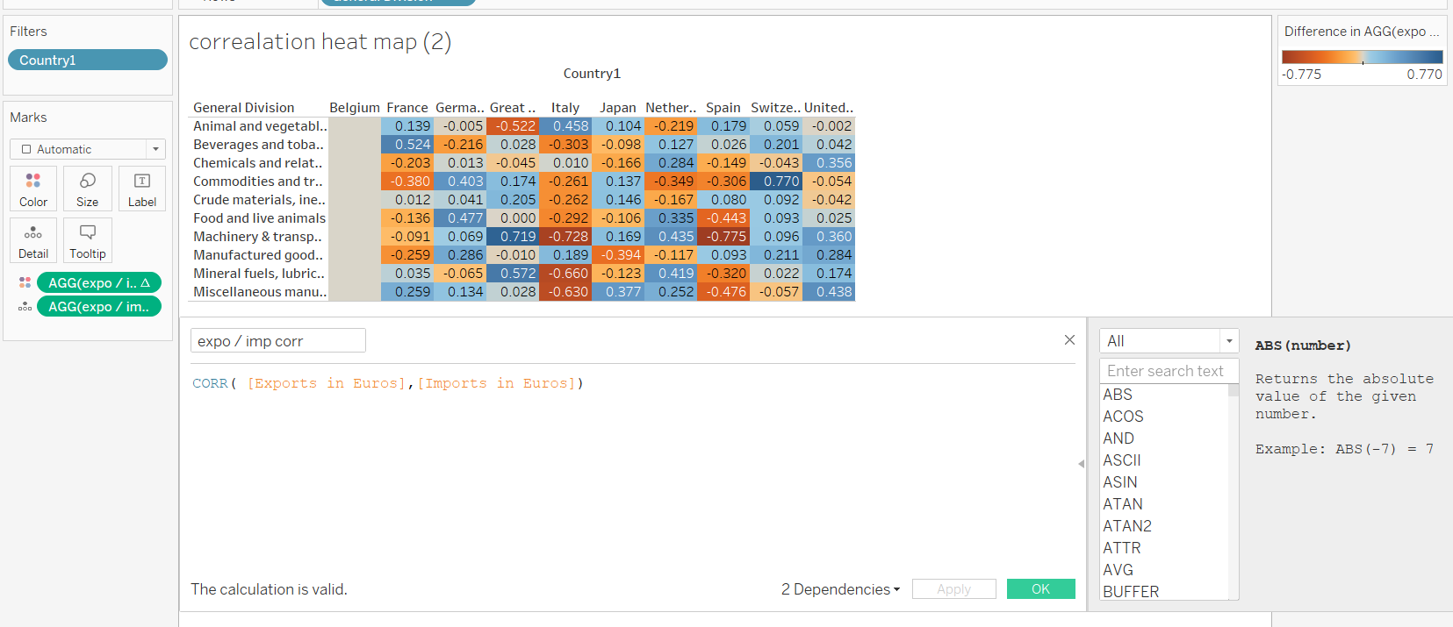

We can also show the R squared number on the heat map, anything with .7 or higher shows a strong positive correlation, with -.7 or higher a strong negative correlation.

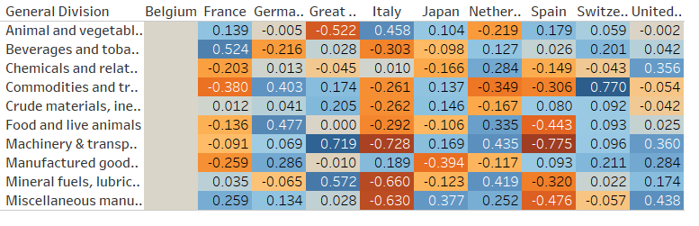We created bubble charts by adding the imports (or exports) to the size, and the general descriptions to both the label and colour. We then select the bubble chart from the show me section.

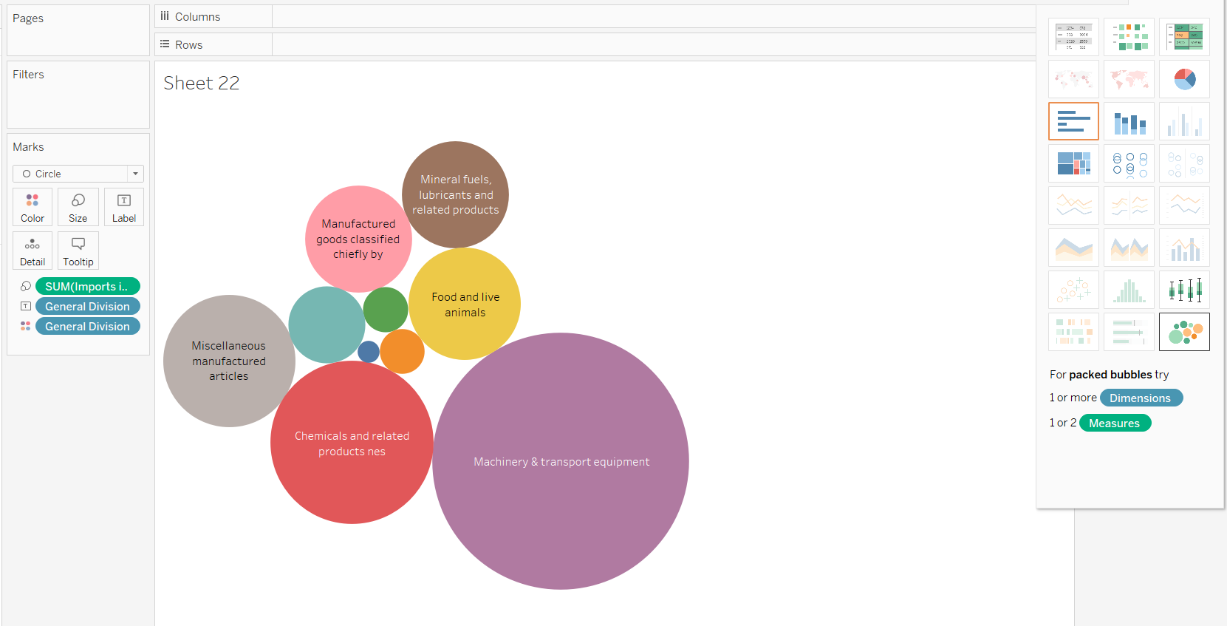

We plotted the exports and imports over a twenty-year period, then we went to the analytics tab and add trendlines and a forecast.

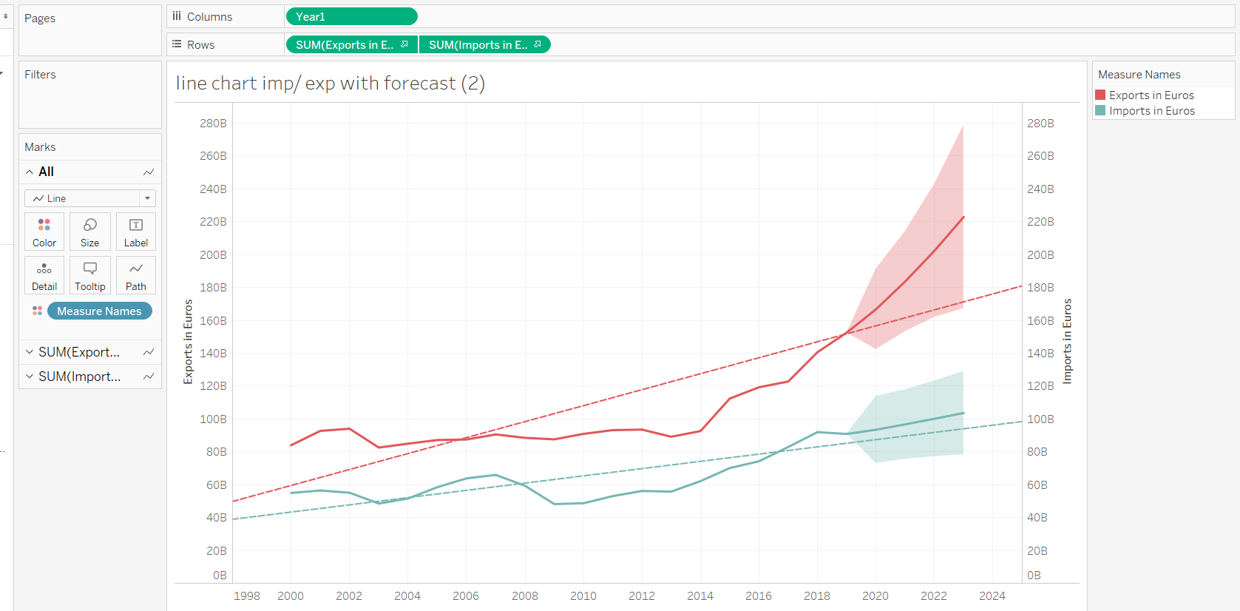

We created a calculated field to assign GB to one colour and the rest of the countries to another colour. This was to highlight the impact of the GB as a market.

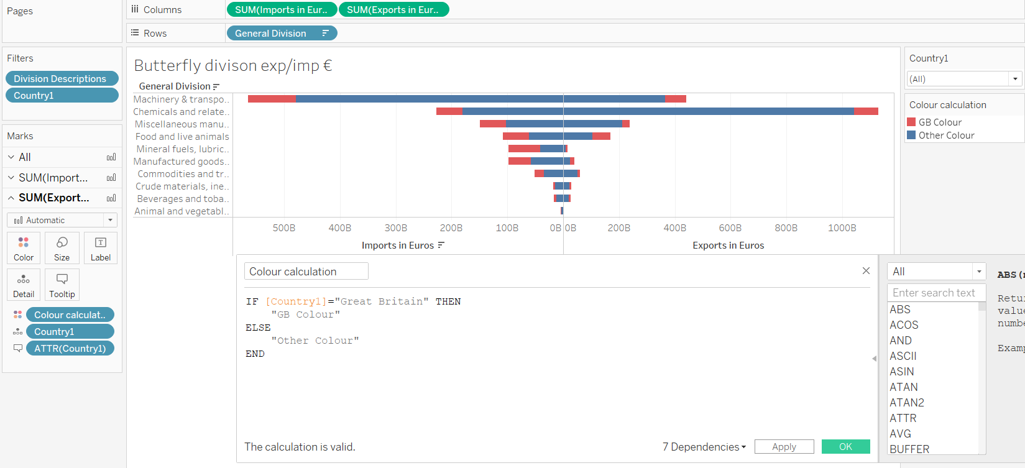

When exploring the division further, we use the division description as a filter, and selected the top 10 by export/import by euro/tonne.

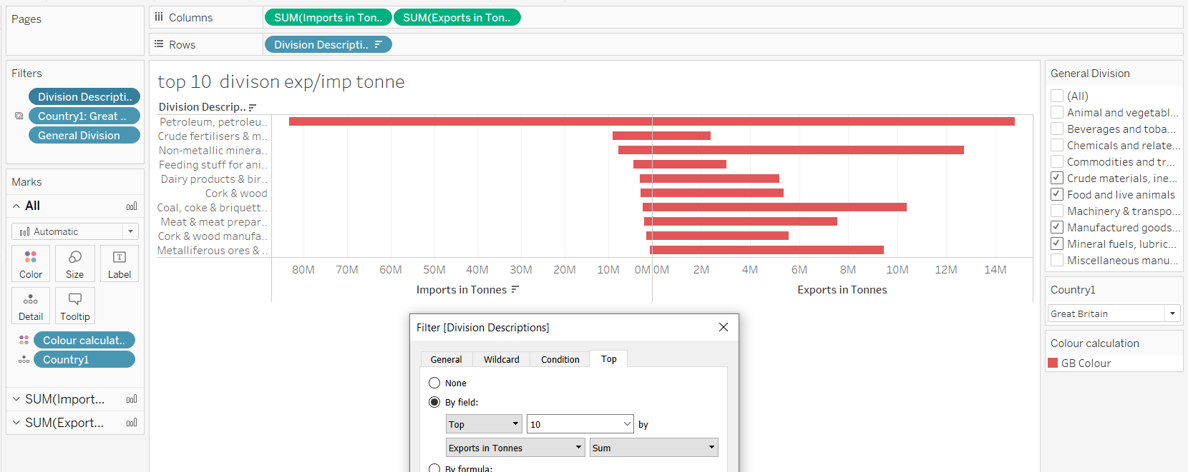

These diverging bar charts had axes on different scales, so to synchronize the axis we right clicked on the larger scales, selected fixed axis and copied the fixed end to the smaller axis.

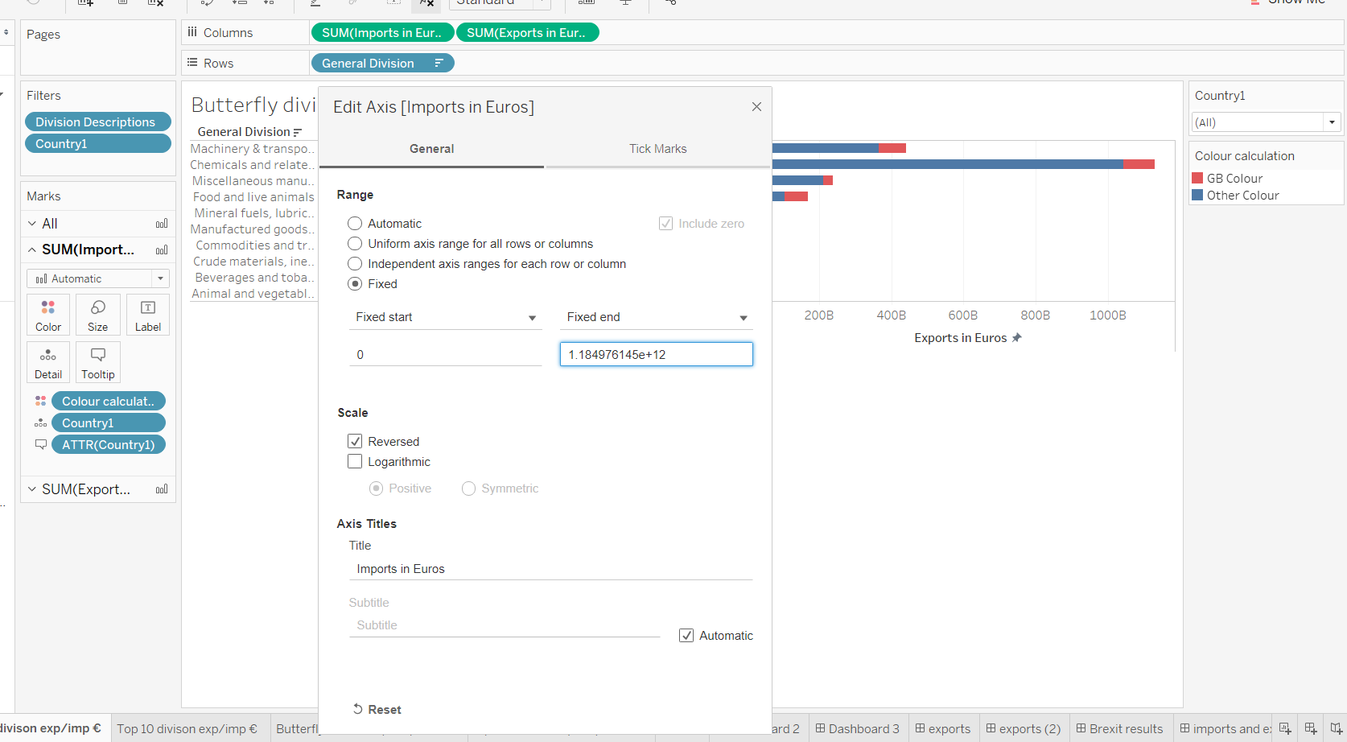

# Creating the story

From the abundance of charts, we created earlier, we selected some of our favourites that were able to convey our goals easily.

We created 3 introduction slides, to outline the goals of the presentation, the target audience, information regarding the data source & visualisation platform, as well as about Ireland's global position and historical ties.

Then, we decided to view the exports and imports in monetary values over a twenty-year period. This was to show the overall story and visualise the upward trend. In the tooltip is another worksheet, sent to show the division descriptor by the point on the graph. We did not use this in the presentation as it would be too busy, but the audience would be able to dig deeper if desired.

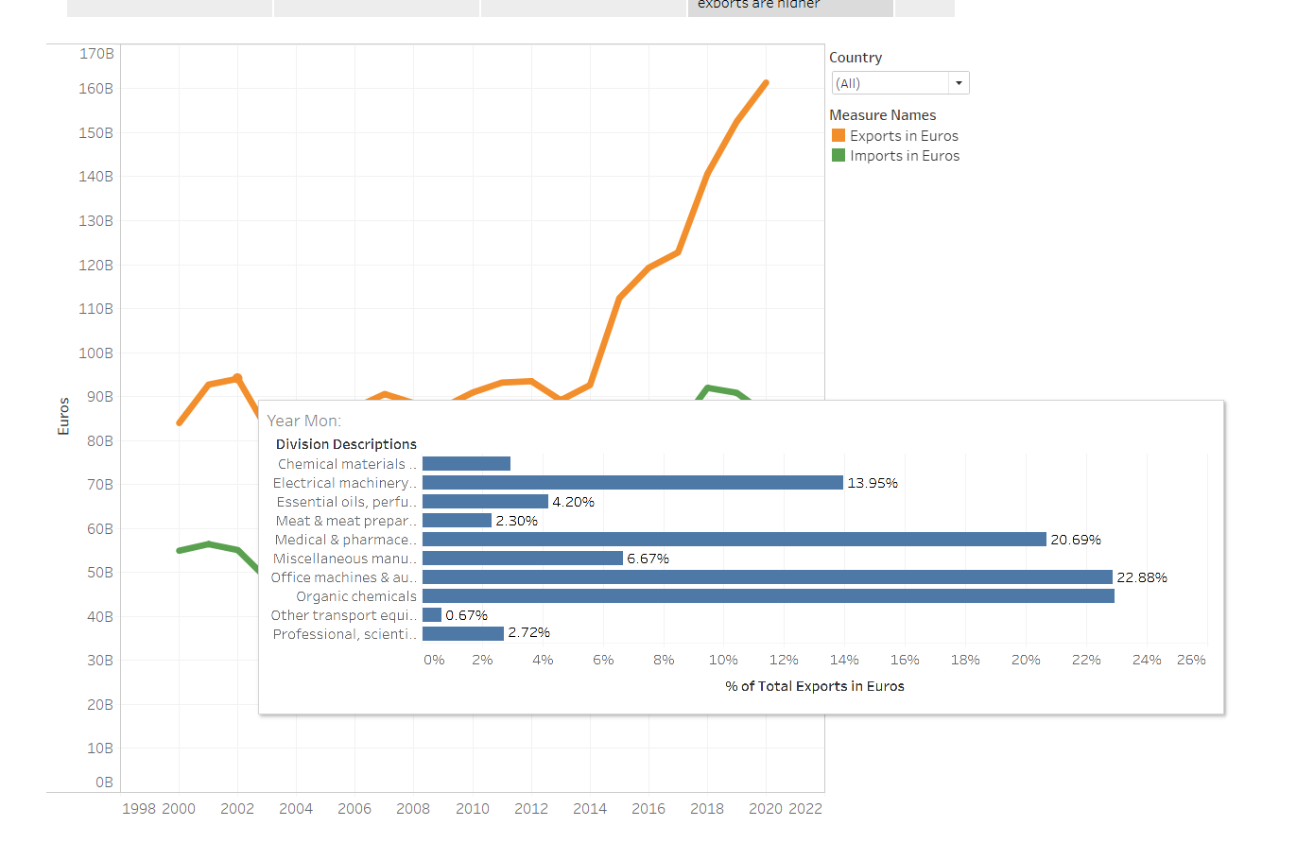

After visualising the overall trend, we wanted to identify our major trade partners. We did so with choropleth maps, using the same colours as before (green to signify imports and gold for exports).

Next, we explored the general division with diverging bar charts. This was used to highlight the relationship of GB and the rest of the countries we trade with. We used the calculated field we created earlier for the colour scheme - We took the red from the GB flag, and the blue from the EU flag (even though the blue bar holds values outside the EU). For the visual, we can see that GB has a significant market share in each division. From here we selected four general divisions for both Euro & tonne and visualised them in the next sheet.

This visualisation showed the smaller divisions that make up the general divisions, and the figures are exclusively for GB. We supplied filters for country and general divisions, so users could visually compare countries.

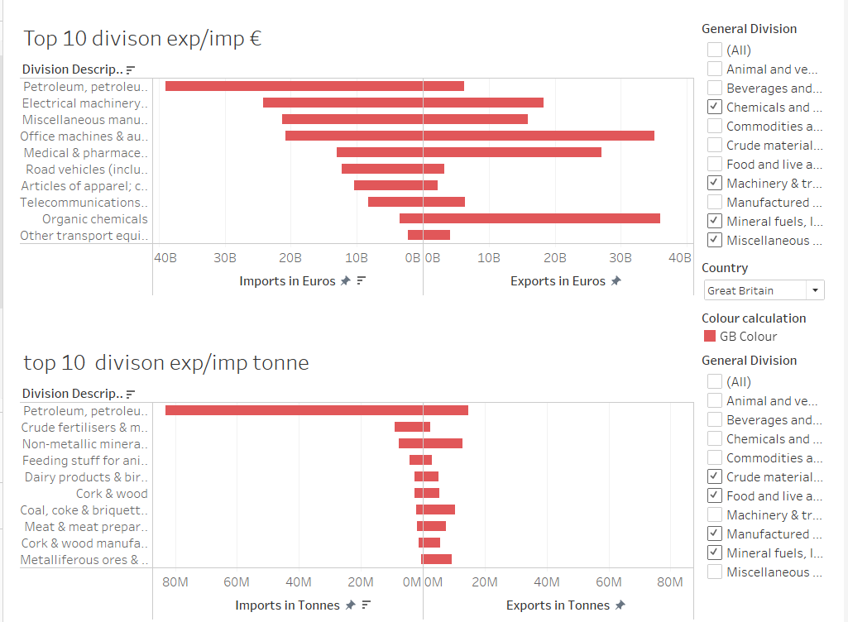

As the data so far has been showing us figures for 20 years, historical values may influence this, so we created the next slide to address this issue. We can see a mostly consistent pattern, with a decline in the most recent year. This may be due to Brexit, or the pandemic.

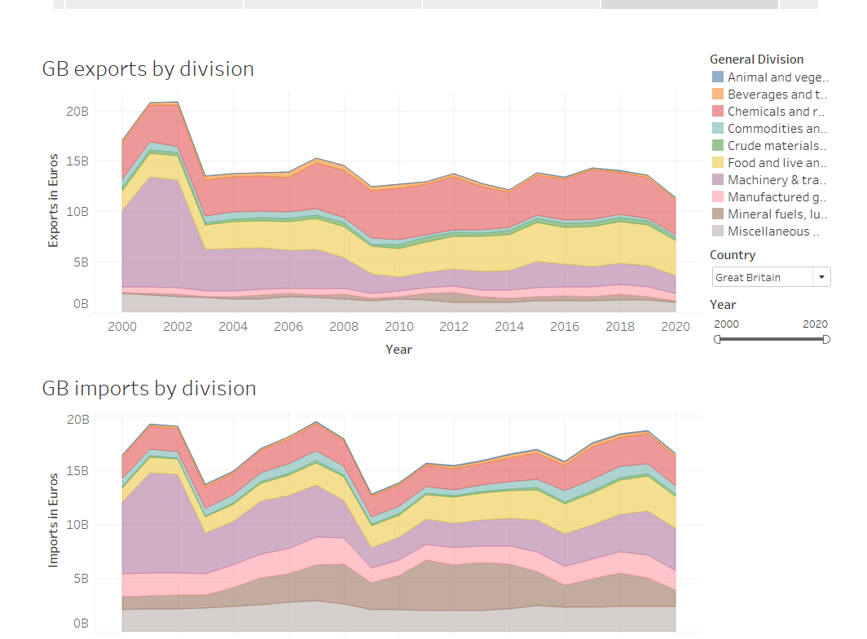

After exploring the relationship with GB, we wanted to highlight some of the issues caused by Brexit, which included an estimated decline of 3-8% in GDP, imports and exports. The table was sourced from a report by the [department of Business, enterprise and innovation for the government of Ireland.](https://enterprise.gov.ie/en/Publications/Publication-files/Ireland-and-the-Impacts-of-Brexit.pdf)

We then used the original import and export map, and applied tableaus forecast and trend line features from its analytics tab. We created two graphs, one including GB and one excluding, both showing a upward trend, but there’s a difference of 20 billion in the forecast without GB.

Lastly, we summarized some of the key points, and focused of the fact that GB was a major partner, but there are ways to continue to trade with them, and we can trade with other markets too.

# Technology used.

Jupyter notebook

Tableau

Excel

Google drive

Paint

# Conclusion

Ireland had a 160 billion worth of export trade with the world in 2020 and Imported worth of 87 billion. The Trend goes up for both Imports and Exports. It is a good sign for Ireland in terms of trade with the outside world. But the recent exit of Great Britain from European Union might cause the fluctuations. But we do not know yet as we are facing the pandemic along the way. The trade relationship with Great Britain is going downwards from the visualizations evidently. But the Brexit should be seen as opportunity for Ireland to attract Investments as it is the only English-speaking country in the European Union. To avoid the downward trend with Great Britain, it should use the Northern Ireland’s relationship to export and import to Great Britain.

I found this work very challenging as the data is enormous to process and bring what we needed. From the visualization part, the trend, the general divisions that contributed for this trend is shown clearly. We tried to visualize the imports and exports based on general categories with Great Britain and to the rest of the world in terms of monetary value and amount of weight. I believe it came out precisely. We tried show the flow of categories down the year with Great Britain and that has come out nicely. The trends for Ireland Imports and Exports are giving us clear idea of what we are facing now.

Shane and I work well together. It is evident from this project and previous projects too. We were able to schedule the timings for this project and finish it on time.

# Reflections on learning

We were able explore the tools available in Tableau. Adopted the learnings on the previous module and applied here. First time working on the time series data gave a great insight on the different types of trends and forecasts. Working on the data pre-processing on python gave us a great learning on pandas library and excel pivoting options. This project gave us a confidence to do more complicated ones in the future.

# References

[https://www.cso.ie/en/interactivezone/visualisationtools/brexitindicators/#](https://www.cso.ie/en/interactivezone/visualisationtools/brexitindicators/)

<https://www.theguardian.com/money/2021/mar/22/bike-poland-brexit-customs-duty-vat>

<https://www.cso.ie/en/statistics/externaltrade/archive/releasearchive2020/>

<https://enterprise.gov.ie/en/Publications/Publication-files/Ireland-and-the-Impacts-of-Brexit.pdf>

<https://www.citizensinformation.ie/en/government_in_ireland/ireland_and_the_uk/brexit_and_you.html>

<https://www.youtube.com/watch?v=vhrmmvAvOfQ>